2.5 Curvature

We will now explore the notion of curvature. We begin by reviewing some terminology.

Definition: A parameterization is called smooth on an interval I if is continuous and . A curve is smooth if it has a smooth parameterization. A smooth curve has no sharp corners or cusps.

Remark: For a smooth curve given by when the unit tangent vector, , turns it does so continuously.
When a smooth curve has sharp turns will turn quickly. When a curve turns quite slowly, will not turn quickly. Consider the pictures below for examples of this idea.

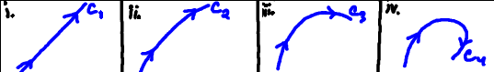

This leads to the following definition.

Definition: The curvature of a smooth curve is .

Theorem: The curvature of a smooth curve given by can be expressed as
- .
OR

Proof:
- First, note that by the chain rule that . By the Fundamental Theorem of Calculus we know that . Since the curve is smooth we know that . This means . Finally, we have that which means that as desired.

- We know, by definition, that .
We also know, by definition, that and by (a) we know that therefore we can see that .
If we use this to substitute into we obtain that .
If we now compute we obtain:
However, since is a unit vector it follows that .
Therefore, we have that

Note: Part (b) of this theorem will tend to be more useful since it only requires that we know the vector-valued function , we don’t need to compute the tangent vector , and we can easily change the parameter if needed.

Example 1: Consider the circle given by where and . Find the curvature of this circle.

We note that and . So we calculate that:
and
Therefore,

OR (using (1) from the theorem to calculate the curvature)

We note that . This means We note from the above calculation that and . So, by the above theorem the curvature is .

Note: Intuitively this means that if a circle has a small radius, its curvature is high. This makes sense because small circles turn more abruptly than large circles.

Example 2: Let C be the ellipse oriented counterclockwise. Measure the curvature at each endpoint of its major and minor axes.

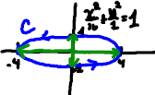
We note that .
So, and

The endpoints on the positive x and y-axis occur at and . The curvature at the points on the x-axis are the same and the curvature on the y-axis are the same.

At :  Therefore, | At :  Therefore,

